12 WATT PLUG IN DRIVER

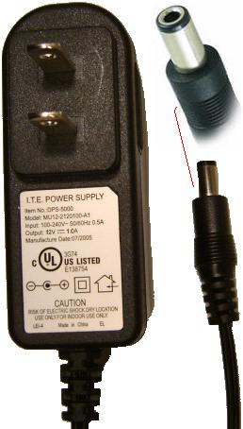

E336754

Class 2
Input: 100-240VAC .5A 50/60Hz
Output: 12V DC 1 Amp

