24 WATT PLUG IN DRIVER

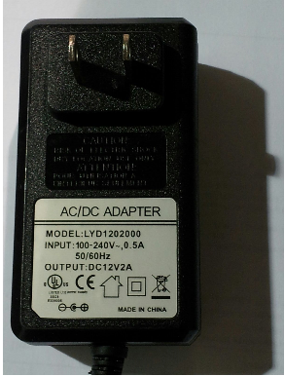

E336005

Class 2
Input: 100-240VAC .5A 50/60Hz
Output: 12V DC 2 Amp

