36 WATT PLUG IN DRIVER

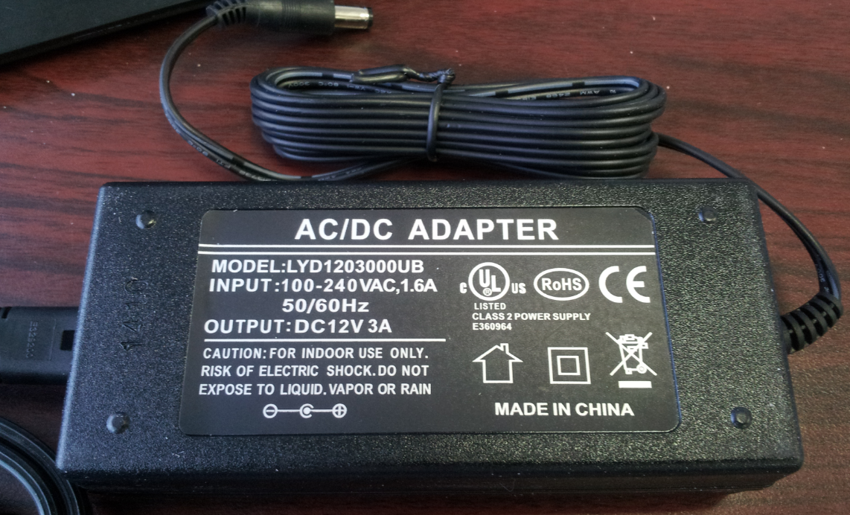

E360964

Class 2
Input: 100-240VAC 1.6Amp 50/60Hz
Output: 12V DC 3Amp
1.30” D x 2” W x 5” L

