60 WATT PLUG IN DRIVER

E360964
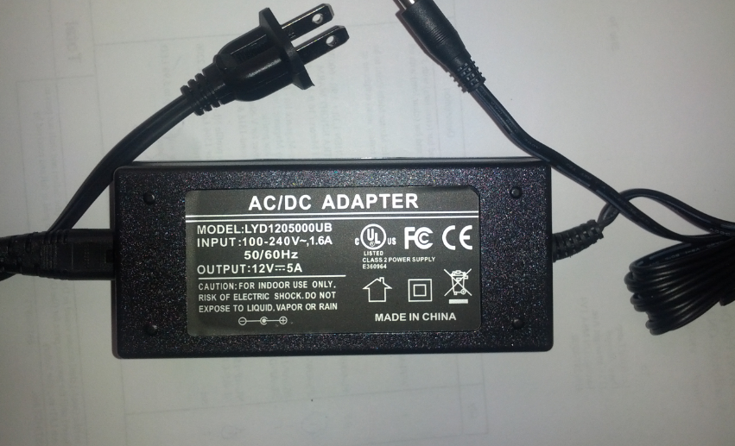

Class 2
Input: 100-240VAC 1.2A 50/60Hz
Output: 12V DC 5 Amp
1.5” D x 2” W x 5” L

