96 WATT 24V PLUG IN DRIVER

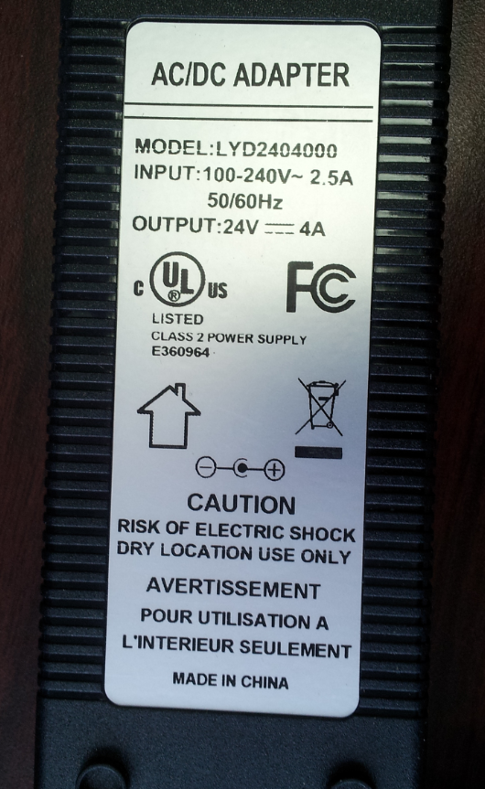

E360964

Class 2
Input: 100-240VAC 2.5A 50/60Hz
Output: 24V DC 4 Amp
1.5” D x 2.4” W x 6” L

